Naresh and Co
Profile Document

11th November 2025, Chennai

Our Services:

NARESH AND CO offers end-to-end engineering solutions, constructions, Installation and Commissioning of telecom wireless and wireline equipment’s and network such as,
- Survey, Installation and Commissioning of all Telecom Equipment’s
- IBS Poles and Micro Towers (up to 16 Meters)
- Macro Towers up to 55 meters (GPT and RTT)
- Engineering Services such as commissioning and integration
- Deployment of 2G, 3G, 4G,5G, MW and Microwave hops
- WIFI, IWAN, FTTH and FTTB Network Design and Installation
- Wire line Services such as Copper and OFC project rollout
- Civil and Passive Infrastructure supply and erection such as DG sets, AMF Pannels etc
- Warranty and post warranty Maintenance.
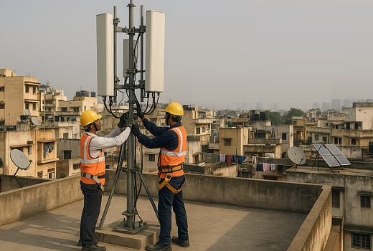
For all the Telecom projects and outsourcing activities we have specific customized solutions and highly trained and skilled team of experts and professionals specialized in the execution of such contracts and have the ability to respond to the most demanding challenges.
Our commitment to the telecom sector is also demonstrated by our substantial skills and investment in the tools and training on the latest technologies, enabling us to execute the projects with the highest level of efficiency.
Our Range of Services:
1. Wireless Communication Networks
1.1 Survey:
- RF Survey
- LOS Survey
- Candidate Short-listing

1.2 Engineering Services:
- Consultancy Services for MSC, BSC and Office Premises
- Layout planning , Design and Approval
- Integration, Configuration and Traffic routing
___________________________________________________________________________
1.3 Installation & Commissioning Services for Telecom / Transmission Equipment:
- I&C Services for BTS (GSM/CDMA/3G/4G/IBS)
- I&C Services for Micro Wave Swap and New Hops
- I&C Services for BSC /XCDR/RNC & Ancillaries
- I&C Services for MSC
- In Building Solutions (IBS)
1.4 WIFI, IWAN Network Design and Installation
- WIFI Network Design for ID/OD Access Point based on design guideline
- WIFI coverage predictions
- WIFI frequency planning and channel allocation
- Installation of Access Point, Antenna’s and Access Switches
- CAT 6 cable supply, laying and Termination with RJ 45, M12 connectors
- Configuration and commissioning of AP’s and Switches
- Post commissioning walk testing
1.4 Wire Line Services:
- Installation and Commissioning of MSAN Equipment’s for RSU/DLC and MSU
- Commissioning for Switches, MUX and Routers
- Integration and provisioning of all OEM Switches
- Termination of MDF
- Migration of voice and DSL (copper network) to new equipment’s
- OFC and Copper network deployment
1.5 Civil and Passive Infra Supply and erection
- Constructions of Tower/ Masts/ Poles/ Mono Poles
- Shelters, DG Sets and Power Back-up equipment’s
- Air Conditioners
- Tower Foundation/ Reinforcement
- Lighting and Lightning Solutions
- AC and DC Electrical Distribution systems and Maintenance

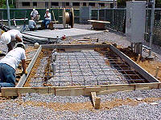
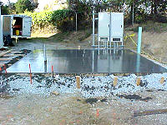
Naresh and Co Telecom and Electrical crews have the capability to handle any size of project. Our in-house personnel are well trained and qualified for full turnkey project completion as well as the activity based projects.

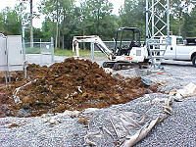
We have an extensive resume of completed projects that include Cellular Towe construction for all telecom equipment’s We construct sites on rooftops, in buildings, Ground Based towers and all types of structures, including complete electrical circuit distribution for site expansion, and Greenfield sites in all terrains and soil types. We pride ourselves in attention to detail and adherence to project specifications and schedules.

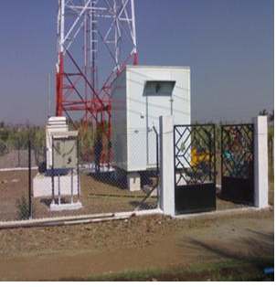
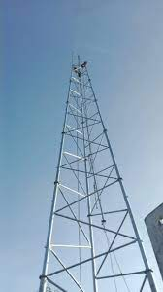
Our Project Management Team closely monitors each job as we continuously update our clients on Milestone completion. The job isn’t complete until you, the customer, is 100% satisfied with the job completed. We always provide professionally prepared documentation packages tailored to your specifications after project completion. We also provide maintenance services for any site related issues. Our team is ready to tackle any size project from a complete market build out to an individual site.
We provide all types of site construction including services such as complete tower unloading assembly and erection, regularly scheduled maintenance, emergency inspection and repair.
Our experience is in the installation and testing of communications systems and Microwave relocation are among the many services supplied by Tower Services, Inc. We have provided our crews with optimization equipment; sweep gear, pair scanning and various other test equipment. We provide testing of all microwave and microwave relocation and transmission line. Our crews are available for emergency work due to bad weather or unexpected circumstances.
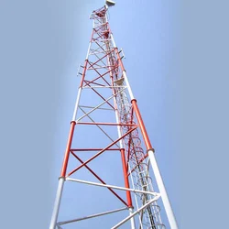
At the core of Professional Services offerings are :
- Pre-installation site readiness survey
- Pick up equipment and deliver to site
- Equipment installation
- Equipment commissioning
- Equipment integration
- Quality inspections
- HW Upgrades (simple and complex configurations)
- Software Upgrades
- Call testing including E911 verification
- Site and network monitoring
- Site and Network Operation and Maintenance Service
Teams will ensure that the delivery of any service is defect free and in accordance with customer specifications and complements of all professional services with:
- The creation and submission of relevant site documents
- Adherence to Health & safety regulations
- Quality Assurance and inspection mechanisms
Project Management
- Telecom Implementation Service
- Roll-Out Management Service
- Turnkey Implementation Management Service

Roll-Out Management Service:
Roll-out management is a full service project management offering. It is a stand-alone service, which can be delivered independent of whoever provides the TI service. It encompasses all services necessary to manage and support the installation, commissioning, integration, and testing and acceptance of the network element components comprising a mobile telecommunications network. This service is limited to management and administration functions and does not include the TI resources necessary to satisfy implementation objectives.
Services provided in this offering may, depending on the defined scope of work, include:
- Management of the customer interface for all issues pertaining to roll-out
- Planning and scheduling of site roll-out in compliance with project roll-out schedule
- Risk Management
- Equipment / materials ordering
- Inventory management
- Telecom Implementation coordination & management
- Health & safety
- Quality Assurance
- Documentation management
- Milestone reporting and update
- Purchase order / change order management
- Invoice reconciliation against purchase orders / change orders
- Cost control
- Acceptance
- Progress reporting
1.6 Operations and Maintenance Services
- O&M Support for DG Sets/PIU/AMF/AC
- Fuel Transactions and EB tractions
- BTS/BSC/MSC round the clock maintenance
- WIFI Network maintenance
- Testing and Optimization
- Competitor coverage drive (Mapping)
- RF Site Integration through single cell functionality test SCFT
- RF optimization through cluster testing and (ATP) testing
______________________________________________________________________
Overall Project Management
Consistently Exceeding Our Clients' Expectations
NARESH AND CO believe the key to a successful project lies in the effective management of all resources through a well-defined system. Also defining the project goals, understanding the specifications, resources, constraints and risks.
- Developing a project plan, which clearly delineates all relationships between the project's stakeholders.
- Executing the project plan by providing the appropriate planning, coordination, and execution of activities to assure the deployment team has the proper control of available resources and relevant processes, effectively delivering the products, services and systems that satisfy the quality level and customer's expectations, as defined in the project goals.
- Developing and managing all appropriate project management documents, including project plan, resource estimates, project budget, project schedule, team roster and assignments, issue management, risk management, change control, and periodic status reports
With Best Regards
Sivam
Director – Naresh and Co

Our customers
Bharti Airtel Ltd
I&C of IBS for Chennai
Micro Sites, Pole erection, civil works, electrical works and Eqp I&C
Site Survey, Test Drive and Iwan
Huawei Telecommunications India Pvt Ltd.
3G Installation and Commissioning, Integration
4G Installation and Commissioning, Integration
MW Installation and Commissioning, Integration, Traffic Migration
MSAN Equipment Installation and Commissioning and Live Traffic Migration
Tech Mahindra Ltd
WIFI Design and Deployment
Data Dimension
Cisco mux installation and commissioning

